Name ___________________________

For each of the following find:
- Vertical Asymptotes
- Horizontal Asymptotes
- Oblique Asymptote
- zeros
- y-intercept
- holes
Then sketch the graph. Check your answer with your calculator or computer.
1)

2)

3)
Key
1)
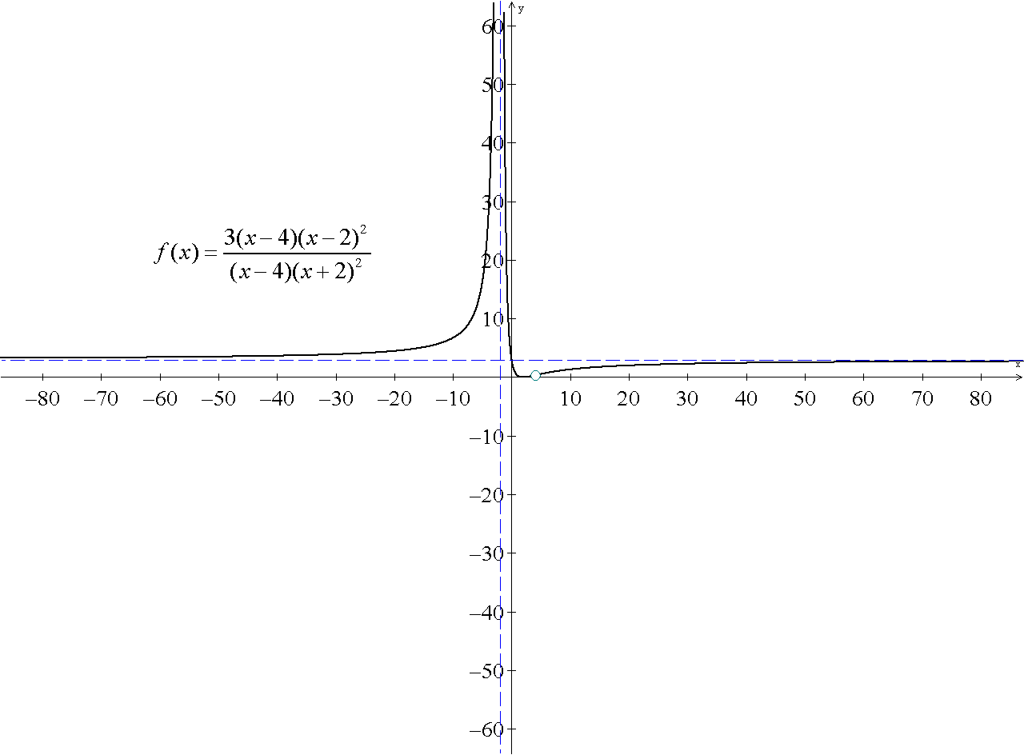
a)
b)
c) none
d)
e) 3
f)
2)
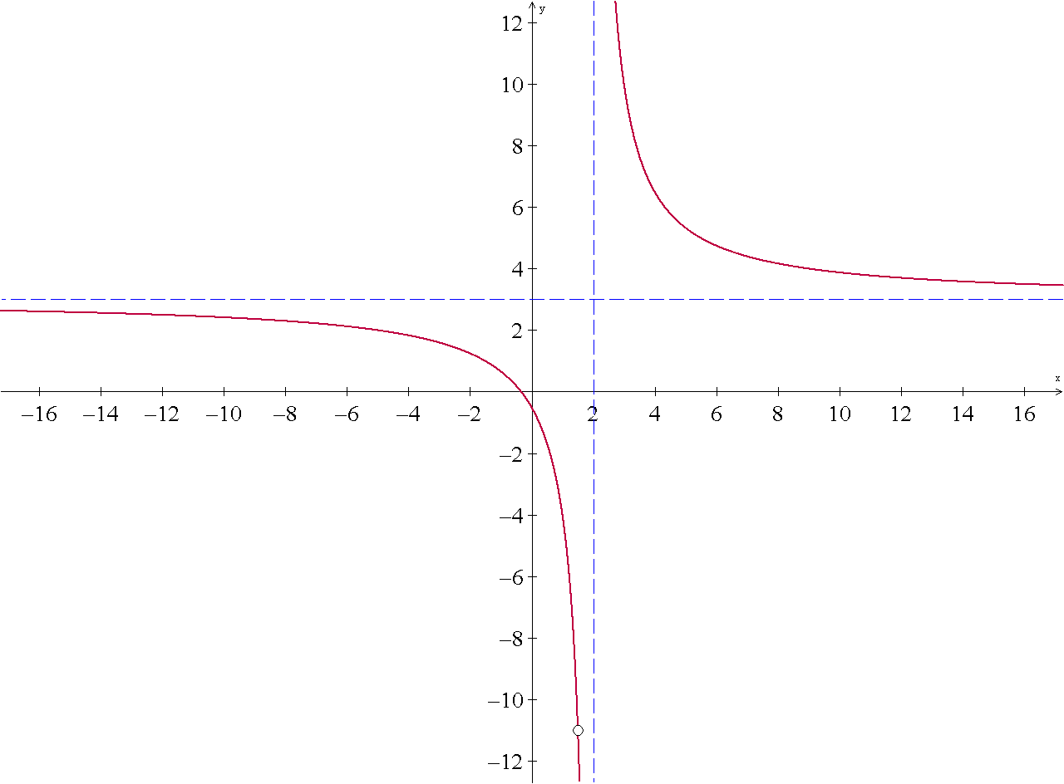
a)
b)
c) none
d)
e)
f)
3)

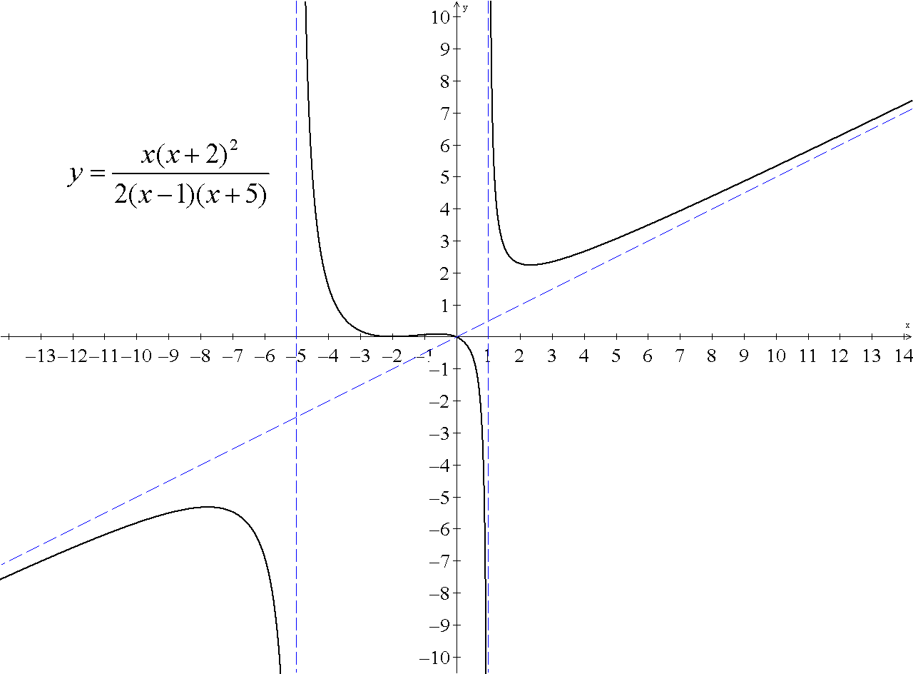

a)
b) none
c)
d) 0, -2
e) 0
f) none

